To: Dr. Christine Cranford

From: Group Members (TJ Adams, Michael Abourched, Gianni Absillis, Wenting Zheng)

Date: 2/28/2019

Subject: Audience Analysis for Jupyter Notebook Installation Instructions

### Purpose

This memo presents the audience analysis conducted for the Jupyter Notebook installation instructions as part of project 2.

### Objective and Audience Definition

Our objective is to instruct numerical analysis students to install the Julia Language on the Jupyter Notebook environment. The Julia language is a high-level programming language aimed at doing data and numerical analysis without worrying about the specific computation implementation details. The primary users of our instructions will be undergraduate data science and numerical analysis students. They will have some basic programming and computer system experience, most likely in Python on a Windows or Mac environment. One group of secondary users will be the professors of these courses, who will have more developed programming experience and a similar experience level on their Windows or Mac environment. Another group of secondary users will be enthusiasts who want to explore data science as a hobby: their programming experience will most likely be limited and varied, and they may only have a rudimentary understanding of their Windows or Mac environment, though this will also vary widely.

### Necessary Information

The user needs to know the system requirements and software prerequisites for following these instructions and how to acquire these. The instructions should not include detailed steps for installing or setting up these prerequisites as they will vary by system and situation. They also need to know where to find the new software components that will be installed by following these instructions and what user inputs or commands are necessary to install the new software components. Installing software also has common problems and errors, the user will need instructions to address these in case they run into these. Frustrations will come from assuming the user understands certain features of their system when they do not. Any non-standard system operations or instructions should be described. Errors will also cause frustration, these will be mitigated by giving solutions to common problems and errors.

Considering that the audience will most likely have some basic programming and computer system experience, they will likely have experience writing commands into the terminal. Because of this, we do not need to give a background explanation of what a terminal is and what it does. We capitalize on this to let the instructions be more concise and to the point. The users will measure their success by determining if Jupyter was installed on their respective machines. We even provide screenshots to show users what a successful installation looks like.

Jupyter Notebook Installation Instruction

These instructions were written for programmers who want to use Julia in Jupyter Notebook. Julia is useful for quickly performing numerical and data analysis. They instruct on how to install Python, Julia and Jupyter Notebook. Installing Python differs between Mac and Windows environments, so make sure you use the correct instructions. We recommend a solid fundamental understanding of your computer environment, specifically file structure, command line, and installation procedures.

1. Open terminal or Command Prompt by double-clicking the icon

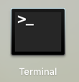 

In Mac: if that icon does not appear in the desktop, search “terminal” with Spotlight.

In Windows: if that icon does not appear in the desktop, press the windows key, type “cmd”, then press enter.

1. Run the following commands to install Jupyter Notebook
   1. If you have Python 3 installed

| python3 -m pip install --upgrade pip python3 -m pip install jupyter |
| --- |

* 1. If you have Python 2 installed or are using Windows

| python -m pip install --upgrade pip python -m pip install jupyter |
| --- |

* 1. If you don’t have Python installed, [download](https://www.python.org/downloads/mac-osx/) and install it. Python 3 is highly recommended.

*Windows Install:*

- Go to <https://www.python.org/downloads/windows/> and install python 3

- Open the download file (.exe files will automatically start installation)

- Follow computer prompts for the download

-After install, add python to path (instructions to do this

<https://edu.google.com/openonline/course-builder/docs/1.10/set-up-course-builder/check->

for-python.html)

- A successful path install will result in the following prompt:



- Ensure python has been installed by typing “python” in command prompt. (A simple

computer search for “command prompt” will bring it up)

*Mac Install:*

- Install homebrew <https://brew.sh/>

- Open terminal and type “brew install python” to install.

- While in the terminal, type “python --version” to verify the download.

* 1. <https://www.python.org/downloads/windows/> (windows link)
  2. If you have windows make sure to check Add Python 3.8 to PATH

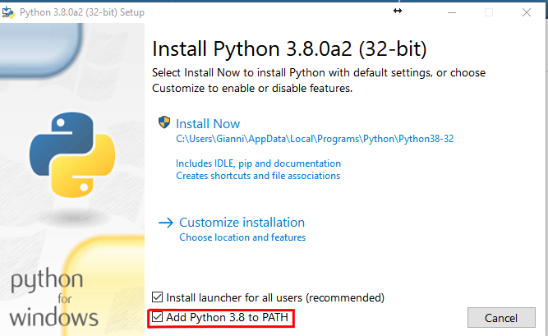

1. [Download](https://julialang.org/downloads/) Julia(0.7 or later) and install it.

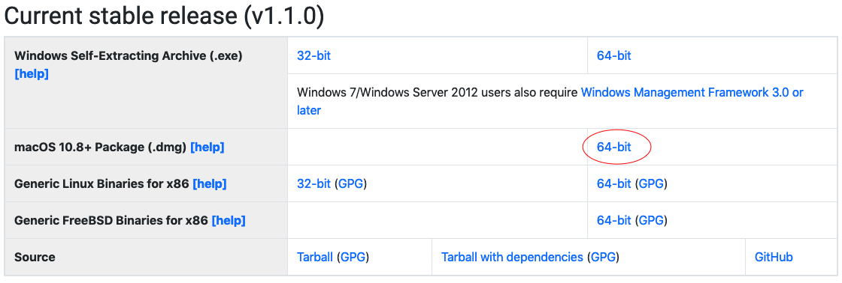

(Windows Users)

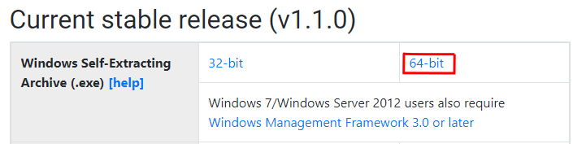

1. Launch Julia by double-clicking the icon.



You should see the following screen in terminal

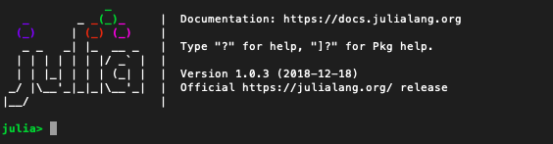

1. Run the following commands in Julia

| julia> using **IJulia** julia> notebook() |
| --- |

* NOTE: be **PATIENT**! The execution may take some time. Please wait until it is completed and julia > shows to enter the next command.
* If the error below occurs use the command

julia> import Pkg; Pkg.add(“IJulia”)

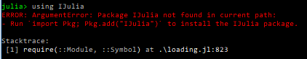

If it asks you to install jupyter via conda type “y” to accept the installation



1. Run the following commands in Julia

| julia> using **IJulia**; notebook(detached=true) **Process**(`'**C**:\**Users**\**JuliaUser**\.julia\v0.7\**Conda**\deps\usr\**Scripts**\jupyter' notebook`, **ProcessRunning**) |
| --- |

* NOTE: Pay attention to the path! If any default paths or changed during installation, reflect it when using this command.

1. Open another terminal window, run the following command

| jupyter notebook |
| --- |

Running this code should open a new tab in your browser like this

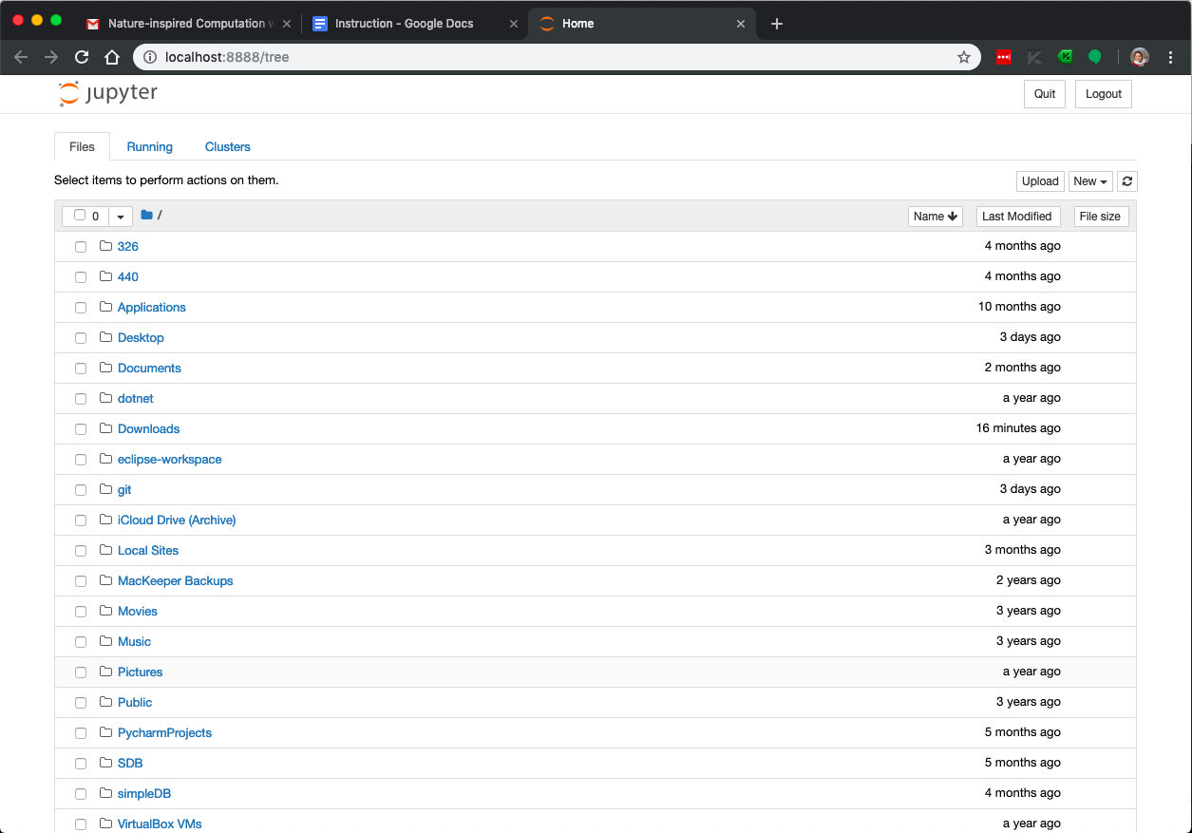

1. Click the dropdown menu labeled New on the right and you should see Julia and Python options.

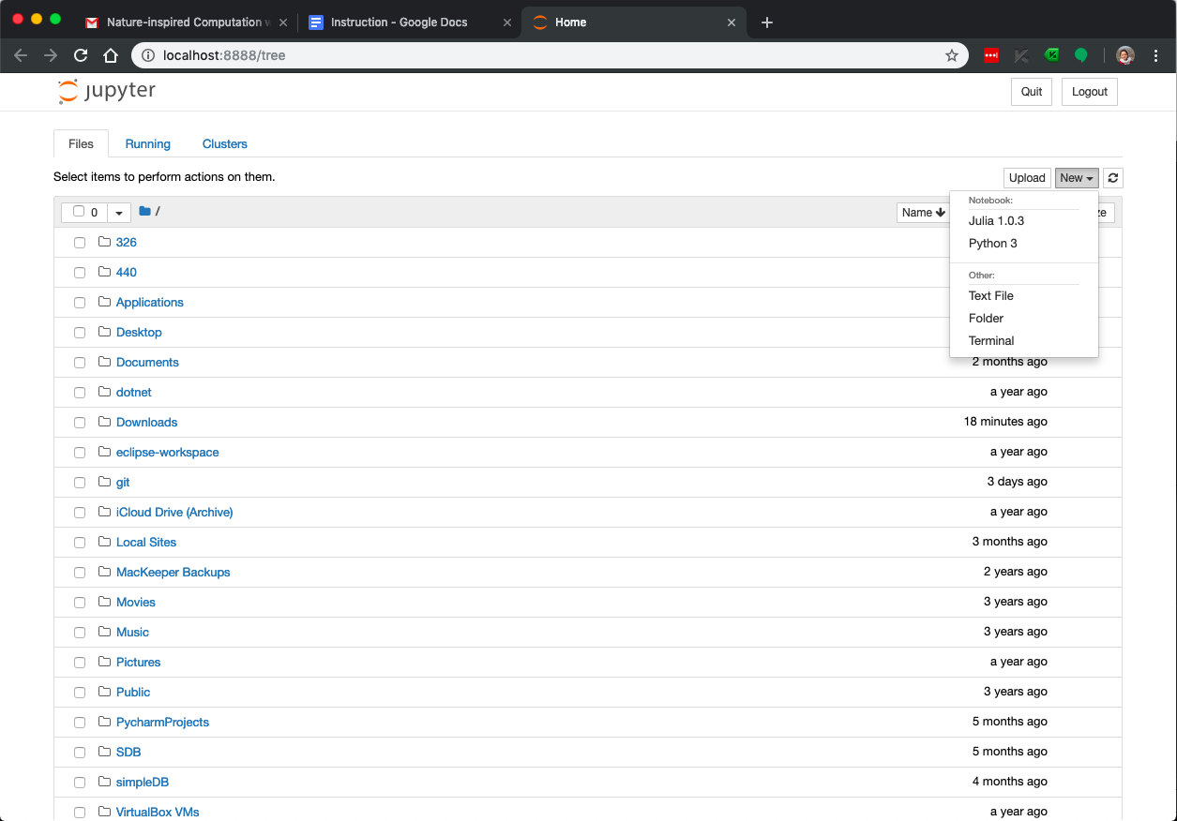

1. Once you see Julia and Python in the dropbox labeled “new”, you’ve successfully installed the package! To learn more about Jupyter, read about the package on their website <https://jupyter.org/>.